**4.REACT JS – HOL**

**Step 1: Create a New React App**

**In your Command Prompt or Terminal, type:**

npx create-react-app blogapp

**Step 2: Open the App in Visual Studio Code**

**In your Command Prompt, run:**

cd blogapp

code .  
  
**Step 3: Create Post.js in src folder**

**In VS Code:**

1. In the Explorer, expand the src folder.
2. Right-click on src → New File → Name it:

“Post.js”

Then type code.

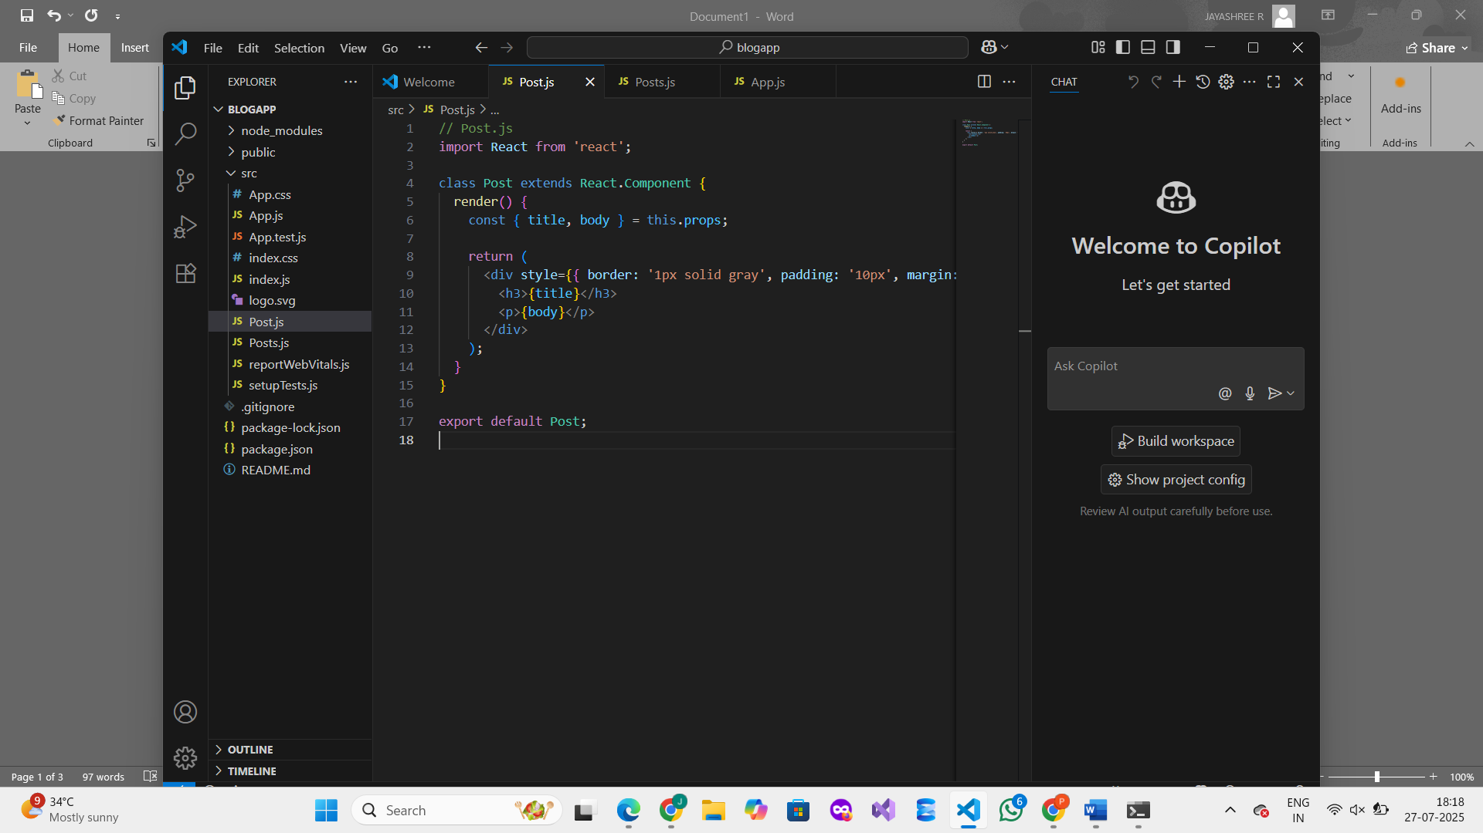

**Step 4: Create Posts.js Class-Based Component**

**In the same src folder:**

1. Right-click on src → New File → Name it:

“Posts.js”   
 2. Then type the code.

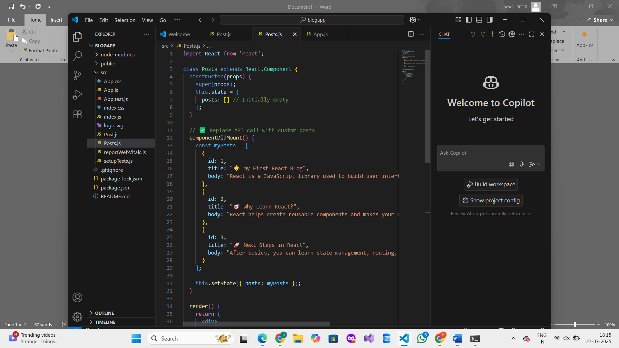

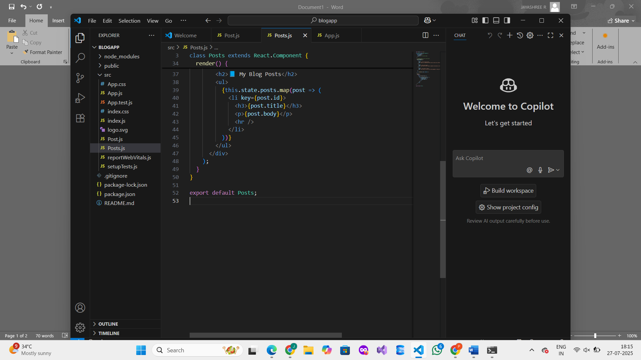

**Step 5 : Add <Posts /> Component to App.js**

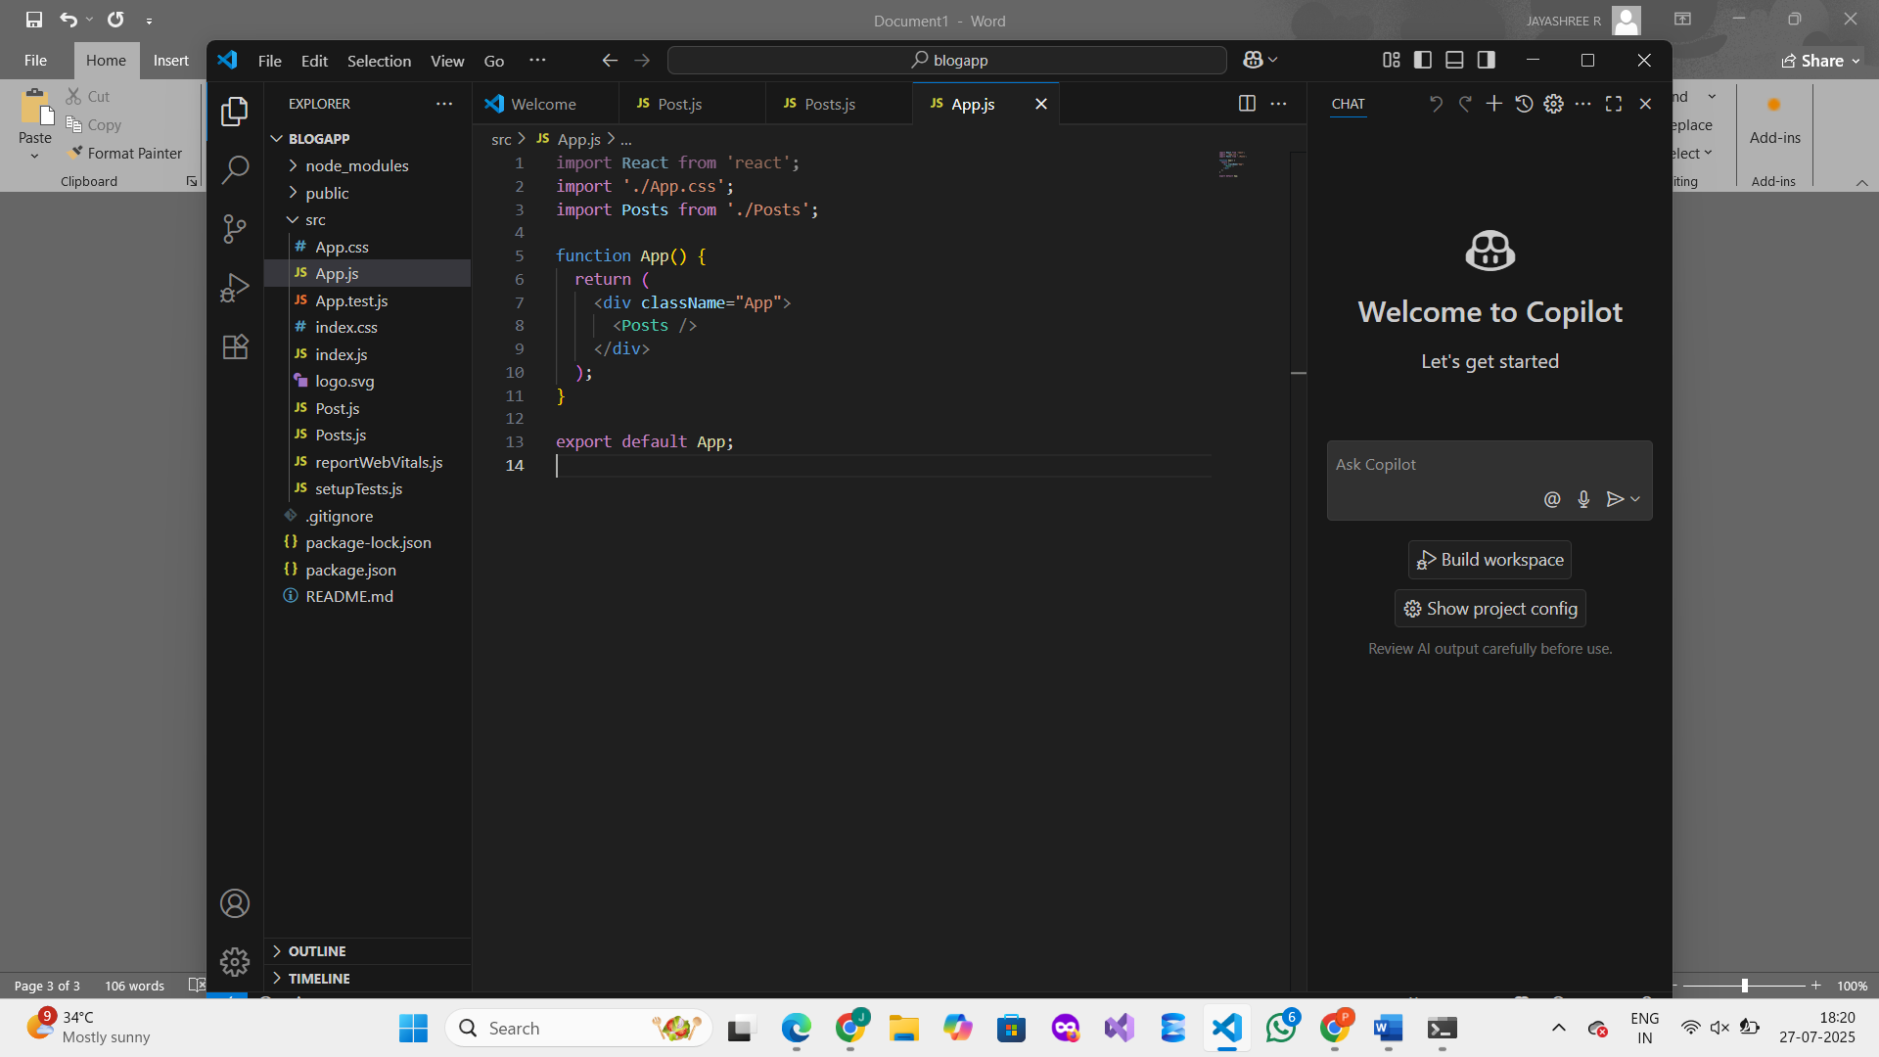

**Step 6 : Run the App**

In your Command Prompt or VS Code Terminal, type:

**npm start**

**OUTPUT :   
